

Software Engineering Department
Braude College of Engineering
Final Project - Phase A (61998)

Real Impact Factor Evaluation Using Deep Learning
26-1-R-10

By:
Roni Brin 318295516
Shaked Turgeman 206180440

Supervisors:
Dr. Renata Avros
Prof. Zeev Volkovich

Link to GitHub

Table of contents

1. Introduction 3
2. Literature Review 4
2.1 Bibliometric Metrics Background 4
2.2 Citation Manipulation and Self-Citation Patterns 4
2.3 Graph-Based Representation of Citation Networks 4
2.4 Graph Embedding and Link Prediction Models 5
2.5 Stability and Robustness in Graph Learning 5
3. Deep Learning Framework for Citation Graphs 6
3.1 Graph Autoencoder Architecture 6
3.2 Pre-trained Graph Embedding Models 6
3.3 Citation Datasets for Training and Evaluation 7
3.3.1 Case of study: OpenAlex 8
3.3.2 Auxiliary material: CiteSeer and PubMed 8
4. Expected Achievements 8
4.1 Stability-Based Evaluation Framework 8
4.2 Baseline IF 8
4.3 Stability Analysis of Citation Edges 9
4.4 RIF 9
4.5 Cross-Year Comparison 9
4.6 Success Criteria 9
5. Proposed Research Plan 9
5.1 Hyperparameters 9
5.2 Methodology 11
5.2.1 Graph Preprocessing 13
5.2.2 Rolling Time-Window 13
5.2.3 Citation stability validation 13
5.2.4 Edge Stability Score 14
5.2.5 RIF Computation 14
5.2.6 Time Trend Dataset Construction 15
6. Evaluation / Verification Plan 16
6.1 Formal Software Testing Strategy 17
7. General Specification 18

Abstract
The evaluation of academic research is largely based on citation metrics such as the Impact Factor (IF). Although widely used, IF is sensitive to citation inflation, structural biases, and coordinated citation behaviors, which may distort the true representation of scientific impact. This project proposes a stability-informed framework for citation evaluation using graph representation learning. Academic publications are modeled as temporal, directed citation graphs, where nodes represent articles and edges represent citation links. The framework applies graph embedding methods, including Node2Vec and deep autoencoder-based models such as VGAE, to learn the structural patterns of the network. The central contribution of this work is a perturbation-based stability mechanism. By repeatedly masking subsets of citation edges and evaluating their reconstruction through link prediction, the system estimates the structural consistency of individual citations. These stability scores are then aggregated to compute the Real Impact Factor (RIF), which either filters or weights citations according to their structural resilience. The proposed RIF provides a structurally informed alternative to IF and aims to reduce the influence of unstable or inflated citation links while preserving meaningful scholarly impact.
Keywords: Real Impact Factor (RIF), Citation Networks, Graph Representation Learning, Link Prediction, Structural Perturbation, Bibliometrics.
- Introduction
The evaluation of academic research plays an important role in funding decisions, institutional ranking, and journal reputation. For decades, bibliometric indicators, most notably the Impact Factor (IF), have been widely used as a primary measure of journal influence [10]. Despite its popularity, the IF has been criticized for its sensitivity to citation inflation and coordinated citation behaviors [8, 9].
Because the IF is calculated as a simple average of citations within a fixed time window, it does not account for the structural context of those citations. This limitation makes the metric vulnerable to skewed citation distributions and strategic citation practices. Recent discussions in the bibliometric literature have highlighted patterns of citation inflation and structural irregularities that cannot be detected through counting-based measures alone [3].
Recent advances in graph representation learning provide new tools for modeling citation networks as structured, temporal graphs. By representing academic publications as nodes and citations as directed edges, it becomes possible to analyze not only citation volume but also structural relationships. Methods such as Node2Vec [5], Variational Graph Auto-Encoders (VGAE) [6] have demonstrated strong performance in learning meaningful embeddings for link prediction and graph reconstruction tasks.
This project proposes a stability-based evaluation framework for citation networks. The core idea is to assess the structural consistency of citation edges through controlled perturbations. By repeatedly masking subsets of citation links and evaluating their reconstruction using graph embedding models, the system estimates a stability score for each citation.
These stability scores are then aggregated to compute the Real Impact Factor (RIF), which adjusts citation contributions based on their structural consistency. The proposed RIF is designed to complement the traditional IF by incorporating structural information into citation-based evaluation.

Literature Review

Bibliometric Metrics Background
The evaluation of academic research heavily relies on bibliometric indicators, with the IF being the most widely recognized metric [10]. Originally developed to assist libraries in making purchasing decisions, the IF is calculated as the average number of citations received by articles published in a journal over the preceding two years [10].
However, these metrics have faced increasing criticism. Because the IF is based on a simple arithmetic mean, it is highly sensitive to skewed distributions, where a small number of highly cited papers can disproportionately inflate the score of the entire journal [10]. Furthermore, studies evaluating various journals (such as medical journals) demonstrate a significant difference between the general academic impact of the articles (often measured by raw citation counts) and their actual level of disruptive innovation [25].
Beyond structural flaws, a major factor distorting these indicators is the phenomenon of "citation inflation". Metrics designed to evaluate academic innovation and impact suffer from an inherent bias due to the continuous growth in scientific publications and citations over time [9]. This natural growth artificially inflates metric values, biases the disruption index, and makes it highly difficult to fairly compare genuine research impact across different time periods [9]. These limitations strongly highlight the need for developing new, more robust, and accurate evaluation methods.

Citation Manipulation and Self-Citation Patterns
In recent years, the scientific publishing system has been dealing with a significant strain and a rapid increase in the number of publications [24]. This reality creates a highly competitive academic environment, which sometimes drives researchers and institutions to use questionable practices to improve their metrics. Furthermore, the massive volume of new publications causes a natural increase in total citation counts (citation inflation). This increase creates statistical "background noise", making it easier to camouflage artificial citations within the expanding citation network [8].
This phenomenon has recently worsened with the introduction of Generative AI (GenAI) tools. Studies indicate that some actors use these tools to quickly generate papers that look academic but lack genuine research content [3]. These papers are often uploaded to open repositories (such as preprint servers) with a clear purpose: to cite each other and create "citation mills". The main goal of these networks is to artificially inflate the impact metrics of a specific group of authors [3]. Such manipulations undermine the credibility of academic evaluation systems, highlighting the need for advanced tools capable of analyzing the citation network to detect these anomalous connections.

Graph-Based Representation of Citation Networks
To analyze and identify complex patterns in academic publication data, it is common practice to represent the data using citation networks. In this environment, the information is modeled as a directed graph. Each node represents an academic article or a journal, and each directed edge between two nodes represents a citation from one article to another [14, 18]. This mathematical representation allows for an accurate modeling of knowledge flow and academic influence.
Since citation networks are not static but continuously evolve and grow, modern studies treat them as temporal graphs [20]. Each addition of a new paper or citation action is considered a single event in time, which alters the topological structure of the network [17]. This dynamic representation is crucial for research and analysis, as it allows us to examine the evolution and stability of connections across different time windows, and to detect structural anomalies that emerge over time.
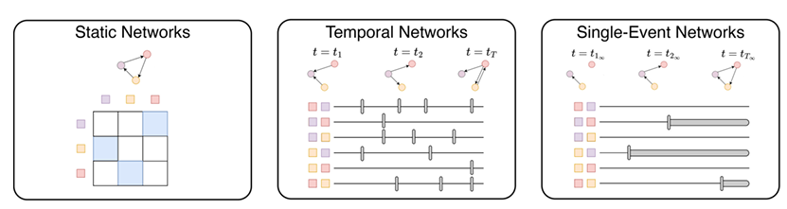
Figure 1 presents a comparison of static, temporal, and single-event network structures [17].

Graph Embedding and Link Prediction Models
To analyze citation networks and identify missing or anomalous connections, link prediction algorithms are widely utilized. Initially, classic models such as Node2Vec offered an efficient approach for learning node representations (embeddings) in a network. This model operates by simulating random walks on the graph, enabling nodes with similar structural roles or neighborhoods to be mapped close to one another in a latent vector space [5].
However, Graph Neural Networks (GNNs) are currently considered the state-of-the-art approach in this domain. Researchers are developing frameworks that integrate heuristic learning with GNNs [13], as well as advanced hybrid approaches [12], to improve the accuracy of link prediction. Despite this rapid progress, studies emphasize the importance of being aware of various pitfalls when evaluating the performance of these models, highlighting the necessity for more rigorous and realistic benchmarking methods [11].
Another prominent family of models used for learning graph representations is based on Autoencoders. Models such as Variational Graph Auto-Encoders (VGAE) allow for the learning of a deep representation of the graph's structure using latent variables, and have demonstrated strong performance in citation network analysis [6]. These graph embedding and link prediction models provide the foundational tools for analyzing citation stability and detecting structurally anomalous citation patterns, which form the basis of the proposed RIF framework.

Stability and Robustness in Graph Learning
The ability of GNN-based models to handle noisy data or intentional biases is a central theme in recent research. While GNNs have shown impressive capabilities in gathering structural information, they have also been found to be vulnerable to small changes in the graph structure, such as the addition or removal of edges [22]. This vulnerability is particularly critical in citation networks, where intentional manipulations can bias model outputs and undermine academic evaluation systems.
To address this challenge, various methods have been developed to boost model robustness. A prominent approach involves using data augmentation by randomly dropping edges during training, which forces the model to learn more stable representations that do not rely on individual connections [21]. Empirical studies suggest that structurally meaningful or strongly integrated edges tend to be more resilient under perturbations, whereas weak, spurious, or adversarial connections are often more sensitive to structural modifications [19, 23]. Understanding these dynamics allows for the use of intentional perturbations as a diagnostic tool to evaluate the reliability of connections within the citation graph.
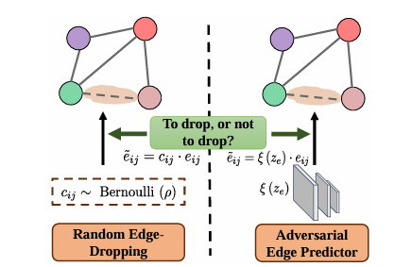

Figure 2 illustrates random and targeted edge dropping during training to encourage more stable graph representations [21].

Deep Learning Framework for Citation Graphs
To address the limitations of traditional bibliometric metrics and the structural vulnerabilities discussed in the previous sections, this chapter presents the proposed deep learning framework for citation graph analysis. The framework is designed to evaluate citation stability through iterative perturbation and reconstruction processes. By combining graph autoencoder architectures with modular embedding models, the system enables a systematic analysis of structural robustness and anomaly detection within dynamic citation networks.

Graph Autoencoder Architecture
In this project, we implement a Graph Autoencoder (GAE) architecture designed for link prediction and stability analysis. The model consists of two primary components: an encoder and a decoder. The encoder utilizes GraphSAGE layers to generate vector representations (embeddings) for each node, accounting for the local neighborhood structure and available node attributes. Subsequently, the decoder employs an inner product operation to estimate the probability of links between node pairs. This structure enables the system to learn the deep structural dependencies within the citation graph and identify connections that remain consistently reconstructable under structural perturbations.

Pre-trained Graph Embedding Models
The core component of the system’s iterative process is the graph embedding module, responsible for generating latent representations used for edge reconstruction and stability evaluation. In order to assess the robustness and structural sensitivity of different learning paradigms, the proposed framework adopts a modular design that enables the integration and comparison of several leading graph embedding models.
We begin with Node2Vec, a classical random-walk-based approach that learns node representations by simulating biased walks across the network [5]. This method preserves both local neighborhood information and broader structural roles, making it a useful baseline for evaluating stability under perturbations.
GraphSAGE represents a more advanced inductive framework based on neighborhood sampling and aggregation [1]. Unlike transductive models, GraphSAGE generalizes to previously unseen nodes, which is particularly important in evolving citation networks where new publications are continuously added. Its aggregation mechanism enables the extraction of structural patterns that are resilient to moderate topological changes.
In addition, probabilistic autoencoder-based approaches such as Variational Graph Auto-Encoders (VGAE) [6]. These models learn latent representations by reconstructing the adjacency structure while regularizing the embedding space.
This modular comparison enables a systematic evaluation of how different embedding paradigms respond to controlled perturbations. By analyzing reconstruction consistency and anomaly sensitivity across models, the framework identifies the architecture most suitable for stability-based citation evaluation.
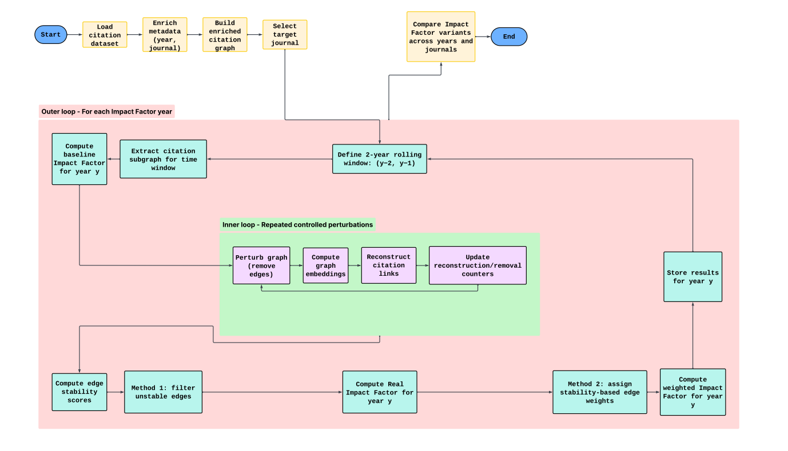
Figure 3 presents an overview of the proposed RIF framework, including the outer yearly loop for citation subgraph extraction and the inner stability loop for perturbation and reconstruction.

Citation Datasets for Training and Evaluation
The evaluation of citation stability and the computation of the proposed RIF require both large-scale real-world citation data and controlled benchmark environments. Therefore, this study adopts a dual-dataset strategy consisting of a primary dataset for full-scale evaluation and benchmark datasets for validation and feasibility testing.

Case of study: OpenAlex
The primary dataset used in this research is OpenAlex, a large-scale open academic knowledge graph that extends the former Microsoft Academic Graph. OpenAlex provides comprehensive metadata, including works (papers), journals, citation links, publication years, and fields of study. This rich structure enables the construction of journal-level citation networks across multiple decades.
The availability of publication year metadata allows the extraction of rolling two-year citation windows, which are required for standard IF computation. Unlike static benchmark graphs, OpenAlex supports longitudinal analysis, cross-year comparisons, and journal-level aggregation. These properties are essential for implementing the outer yearly loop of the proposed framework and for computing both baseline and stability-adjusted IF variants.
Due to its scale and temporal depth, OpenAlex serves as the main dataset for structural perturbation analysis, edge stability computation, and RIF evaluation.

Auxiliary material: CiteSeer and PubMed
In addition to OpenAlex, the study utilizes two widely adopted benchmark citation datasets: CiteSeer and PubMed. These datasets are commonly used in graph machine learning research for link prediction and node representation learning tasks.
CiteSeer consists of scientific publications in the computer science domain, while PubMed represents a biomedical citation network. In both datasets, each node is associated with a feature vector derived from the paper’s content. Although typically treated as static graphs, the presence of publication metadata enables a simplified temporal interpretation.
These benchmark datasets are not used for full RIF computation, as they lack the journal-level granularity and temporal depth required for multi-year bibliometric analysis. Instead, they serve as controlled environments for validating embedding stability, reconstruction consistency, and perturbation sensitivity across different graph embedding architectures.
By combining large-scale real-world citation data with standardized benchmark datasets, the proposed framework ensures both practical applicability and methodological rigor in evaluating citation stability and structural robustness.

Expected Achievements
This chapter describes the expected outputs of the system and the measurable goals of the project. The main objective is to build a working framework that analyzes citation stability and produces a stability-based alternative to the traditional IF.

Stability-Based Evaluation Framework
The first expected result is a fully operational system that evaluates citation stability using controlled structural perturbations. For each target year, the system extracts a two-year rolling citation subgraph and applies repeated edge perturbations. The system then recomputes the graph embeddings and reconstructs the citation links. Across multiple iterations, the framework records how often each citation edge is successfully reconstructed. This process produces a quantitative stability score for every citation edge, serving as the main structural output of the framework.

Baseline IF
The system will compute the traditional IF using standard two-year rolling windows. This serves as a reference metric and a comparison baseline, providing a methodological foundation to clearly demonstrate the differences between traditional and stability-based evaluation approaches.

Stability Analysis of Citation Edges
Using the reconstruction results from the inner loop, the system will classify citation edges according to their structural stability. Each edge will receive a numerical stability score based on its reconstruction frequency. This mechanism allows for the identification of stable citations, the detection of weak or unstable links, and the statistical analysis of stability distributions per journal and year.

RIF
The primary contribution of the project is the calculation of the proposed RIF. Two alternative approaches will be implemented:
- Method 1: Filtered IF: Unstable citation edges are explicitly removed from the network before computing the metric.
- Method 2: Weighted IF: Each citation is weighted proportionally according to its derived stability score.
Both approaches aim to systematically reduce the influence of unstable or potentially manipulated citations.

Cross-Year Comparison
The system will comprehensively store the results for each year, including the Baseline IF, stability scores, Filtered IF, and Weighted IF. This longitudinal database enables cross-year comparisons and allows for the tracking of metric changes and stability trends over time.

Success Criteria
The project will be considered successful if the following conditions are met:
- The embedding models achieve robust link prediction performance, as measured by standard metrics (AUC and AP).
- The citation stability scores demonstrate clear convergence across perturbation iterations.
- The RIF exhibits measurable suitable divergences from the traditional IF in specific cases involving structural irregularities or suspected inflation.
- The system operates successfully end-to-end on the selected datasets, producing reproducible and consistent yearly results.

Proposed Research Plan
This chapter describes the implementation plan of the proposed system, including the model configuration, hyperparameter selection, and evaluation process. The goal is to test different graph embedding models within the stability-based citation analysis framework and identify the most reliable configuration.

Hyperparameters
Graph embedding models require several hyperparameters that affect training performance and stability. In this project, these parameters will be selected based on common settings in the link prediction literature and adjusted through controlled experiments.
GraphSAGE:
For the GraphSAGE model, the primary parameters include:
- Aggregator type (e.g., Mean, Pooling)
- Neighborhood sample size for each layer
- Number of layers (search depth)
- Embedding dimension
The neighborhood sample size determines how many neighboring nodes are aggregated at each layer. The number of layers controls how far information propagates in the graph.
Node2Vec:
For the Node2Vec model, the main parameters include:
- Embedding dimension
- Number of walks per node
- Walk length
- Return parameter (p)
- In-out parameter (q)
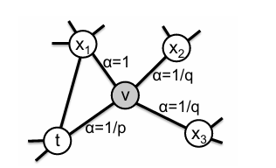
The parameters p and q control how the random walks explore the graph. They balance between exploring local neighborhoods and capturing broader structural patterns.

Figure 4 illustrates the random walk mechanism in Node2Vec, where transition probabilities are controlled by search bias parameters $α$ [5].
The transition probability for the random walk is defined as:
$P(c_{i}=x|c_{i-1}=v)∝α_{pq}(t,x)$
Where the search bias $α_{pq}(t,x)$ is determined by:
$α_{pq}\left(t,x\right)=\left\{\begin{aligned}\frac{1}{p} if x=t \\ 1 if x adjacent to t \\ \frac{1}{q} otherwise\end{aligned}\right.$
VGAE:
For the Variational Graph Autoencoder (VGAE), the configuration includes:
- Hidden layer size
- Latent embedding dimension
- Learning rate
- Number of training epochs
The encoder is implemented using Graph Convolutional Network (GCN) layers. Training will be performed using the Adam optimizer.

Methodology
This section describes the computational pipeline of the proposed system, from raw citation data to the final metric calculation.

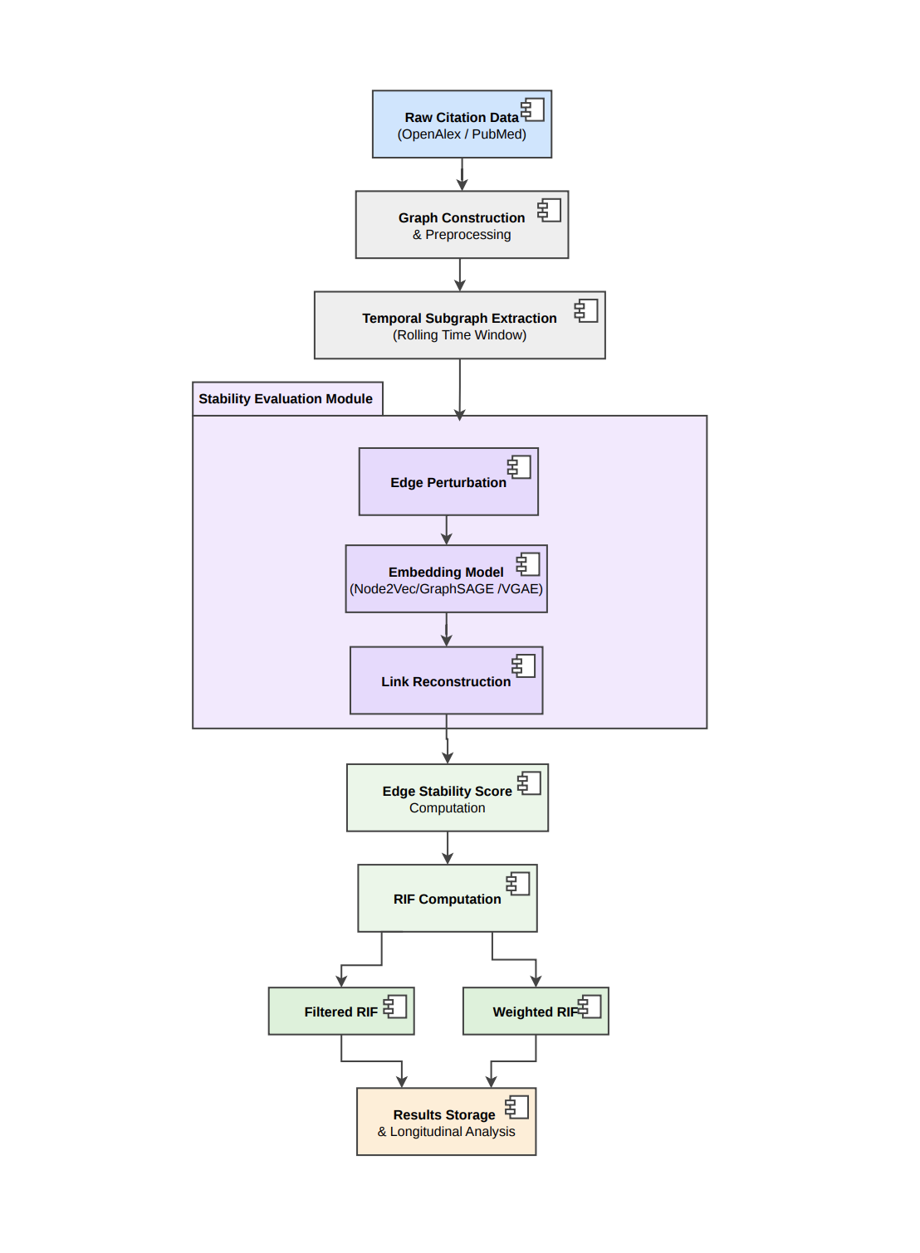

Figure 5 presents the architecture of the proposed RIF framework, illustrating the pipeline from citation data processing and stability evaluation to the computation of filtered and weighted RIF metrics.

Graph Preprocessing
The first step is converting the raw citation data into a structured graph representation suitable for graph learning models. The citation network is defined as a directed attributed graph: G = (V, E, X), where:
- V represents the set of papers (nodes)
- E represents the citation links (edges)
- X is the node feature matrix
The adjacency matrix A is constructed directly from the citation links. For models that use Graph Convolutional layers (e.g., VGAE), the adjacency matrix is preprocessed as follows: self-loops are added to preserve node information, and the matrix is symmetrically normalized. Additionally, the node feature matrix X is row-normalized to maintain consistent scaling across features. This preprocessing step ensures that all embedding models receive a unified and stable input representation before the stability iterations begin.
To ensure numerical stability during neighborhood aggregation, the adjacency matrix is symmetrically normalized according to the following formula:
$$\hat{A}={\tilde{D}}^{-\frac{1}{2}}\tilde{A}{\tilde{D}}^{-\frac{1}{2}}$$
Where $\tilde{A}=A+I$ represents the adjacency matrix with added self-loops, and $\tilde{D}$ is the corresponding degree matrix.

Rolling Time-Window
To compute both the traditional IF and the proposed stability-based metrics, the citation network is processed using a rolling time-window approach.
For each target year Y, the system extracts a subgraph that includes:
- Papers published in years Y-1 and Y-2
- Citation links these papers received during year Y
This subgraph represents the active citation structure required for IF computation. Each citation is treated as a single timestamped event.
By extracting only the relevant nodes and edges for year Y, the system ensures that the evaluation is performed on the correct temporal subset of the network. This process is repeated for each target year in the dataset.

Citation stability validation
The computational core of the proposed framework is the inner stability loop, which evaluates the robustness of individual citation edges under repeated structural perturbations. inspired by robustness-oriented graph augmentation techniques, such as ADEdgeDrop, which test network stability under conditions of uncertainty.
For each extracted temporal subgraph, the system performs a predefined number of perturbation iterations. In each iteration, a specific fraction of the citation links is randomly masked or removed. This operation simulates structural noise and tests the network's resilience.
Following the perturbation, the selected graph embedding model (e.g., Node2Vec, GraphSAGE, VGAE) computes new latent representations for the nodes based on the distorted topology. Inductive models like GraphSAGE allow at this stage for the extraction of resilient structural patterns even when key edges are missing. These embeddings are then utilized to reconstruct the graph's edges via a link prediction mechanism.
Throughout this iterative process, the framework maintains tracking counters for every citation edge. The system records both the number of times an edge was masked and the number of times it was successfully reconstructed by the model. After completing all perturbation iterations, a reconstruction rate is computed for each edge as the ratio between successful reconstructions and total removals.
This repeated cycle of perturbation and reconstruction isolates structurally meaningful citation links from spurious, weak, or structurally fragile connections that collapse under the induced noise.
In the case of autoencoder-based models (e.g., VGAE or GAE), the reconstructed adjacency matrix is obtained via an inner product decoder:
$$\hat{A}=σ(ZZ^{T})$$
Where Z represents the learned node embeddings and σ(⋅) is the sigmoid function. The reconstructed edge probabilities are then compared against the removed edges during each perturbation iteration.

Edge Stability Score
Following the completion of all stability iterations for a given time window, the system consolidates the collected data into a final stability score for each citation edge. This score serves as the primary metric by which the framework evaluates the structural stability of every link in the graph based on its reconstruction performance.
The stability score of a citation edge is defined as its empirical reconstruction probability under noise. Mathematically, the score is derived from the reconstruction rate measured during the inner loop. Edges exhibiting a high stability score are those that the model could consistently predict even when significant portions of the surrounding topology were removed, indicating that these links are structurally consistent with the learned graph representation.
At this stage, these stability scores can also be analyzed at the article or journal level to identify broader structural patterns within specific datasets. These scores serve as direct inputs for the subsequent citation filtering and weighting stages, forming the foundation for the RIF computation.

RIF Computation
The final stage of the proposed methodology is the computation of the RIF. Unlike the traditional IF, which assigns equal weight to every citation, the RIF weights citation contributions based on their structural stability as measured during the reconstruction process. The framework implements two complementary approaches for this calculation:
- Threshold-Based Filtering: In this approach, citations are retained only if their stability score exceeds a predefined threshold. Edges failing to meet this structural stability criterion are removed from the impact computation. The resulting metric reflects journal influence derived exclusively from citation links that remain structurally consistent under repeated perturbations.
- Probabilistic Weighting: In this approach, rather than binary exclusion, each citation contributes to the overall count proportionally to its stability score. For example, a citation with a stability score of 0.9 is counted nearly as a full citation, whereas a citation with a score of 0.3 contributes less significantly to the journal’s IF value.
By implementing both approaches, the system enables an evaluation of the differences between hard citation filtering and soft probabilistic correction. The final output is a structurally informed metric that reflects a journal’s scientific impact while mitigating the influence of citation links that exhibit low structural stability.

Time Trend Dataset Construction
The final step in the methodology involves consolidating all iterative outputs into a structured dataset to facilitate longitudinal analysis. This process ensures that stability-informed metrics are not presented as isolated data points but as part of a continuous temporal trend.
The dataset is systematically organized, containing for each record the target year, journal name, baseline IF, and the RIF metrics computed through both filtering and weighting methods. While the initial model evaluation is performed on PubMed data, the system is designed to integrate with OpenAlex as the primary data source for the full multi-year dataset. This choice of OpenAlex supports large-scale longitudinal analysis and enables the identification of metric divergence over time.
This systematic construction serves as the foundation for the results chapter, as it allows for evaluating how stability-informed metrics evolve over time for specific journals. Furthermore, this process may reveal periods characterized by structural fluctuations that are not reflected in classical bibliometric indicators.

Evaluation / Verification Plan
Step | Verification/Test Description | Evaluation Method | Expected Outcome
1 | Data Loading and Graph Construction Test | Validate parsing of citation records and construction of temporal subgraphs. | Graphs are correctly constructed. Adjacency matrices are normalized. Extracted subgraphs match expected time-window sizes.
2 | Model Execution and Convergence Test | Run embedding models (Node2Vec, GraphSAGE, VGAE) and monitor training stability. | Models initialize and complete training without runtime errors. Loss decreases consistently across epochs.
3 | Baseline Link Prediction Evaluation | Evaluate model ranking quality using Area Under the ROC Curve (AUC) and Average Precision (AP) on validation edges. | Competitive performance (e.g., AUC/AP >= 0.85), confirming meaningful structural embeddings.
4 | Robustness Under Perturbation Test | Gradually increase perturbation fraction (e.g., 10%, 20%, 30%) and measure reconstruction accuracy. | Reconstruction performance degrades gradually (not abruptly), indicating structural resilience of learned embeddings.
5 | Edge Stability Score Validation | Compute reconstruction rate for each edge and verify score bounds. | Stability scores fall within [0,1]. Stable edges receive high scores; unstable edges receive low scores.
6 | RIF Computation Verification | Apply filtering and weighting approaches; compare against baseline IF. | RIF is computed successfully. A measurable divergence from IF appears in cases of structural instability.
7 | Cross-Year Consistency Test | Evaluate metric trends across multiple rolling windows. | Stability-informed metrics evolve consistently over time. Significant deviations correspond to structural anomalies.

Formal Software Testing Strategy
To ensure the correctness, stability, and reliability of the developed system, a structured software verification plan is executed. The following table summarizes the formal testing procedures applied across different system layers.
Test Type | Target Component | Test Description and Method | Expected Result
Unit Testing | Time-window extraction + RIF formulas | Feed small dummy citation data with known years. Verify the 2-year slice  (y-2, y-1) and manually compute Baseline IF, Filtered RIF, and Weighted RIF on the same dummy set. | Extracted subgraph contains only the correct years. Metric outputs match manual calculations.
Input/Output Testing | Data loader + graph constructor | Provide valid and invalid citation rows (missing year, non-numeric year, missing IDs, duplicates). Confirm valid rows build a graph and invalid rows are rejected with clear error reporting. | Valid input produces a graph with expected node/edge counts. Invalid input triggers controlled errors and does not corrupt the pipeline.
Integration Testing | Perturbation -> Embedding -> Reconstruction | On a small subgraph, remove a known fraction of edges, run one embedding model (Node2Vec / GraphSAGE, orVGAE), then reconstruct removed links and collect reconstruction outputs. | Pipeline runs end-to-end without dimension/type errors. Reconstruction outputs are produced for the removed edge set.
Determinism / Reproducibility | Stability scoring outputs | Run the same configuration twice on the same fixed subset with fixed random seeds. Compare stability scores and resulting RIF values. | Stability scores and final RIF values are identical (or within a tiny tolerance if a component is nondeterministic).
System Testing | Full yearly loop (outer loop) | Execute the full process for a small time range (e.g. 2-3 years) on a limited subset (single journal or small graph). Store yearly results. | System completes without crashes and produces per-year Baseline IF, Filtered RIF, and Weighted RIF outputs in the expected format.
Unit Testing | Graph Integrity / Sanity Checks | Construct controlled graphs containing edge cases: self-loops, duplicate edges, missing node identifiers, and direction inconsistencies. Validate that preprocessing enforces the defined graph rules (e.g. remove self-loops, merge duplicates, preserve directed structure). | The resulting graph satisfies structural constraints: no invalid nodes, no unintended duplicates, and directionality matches the defined citation model.
Unit Testing | Stability Score Computation + Threshold Logic | Provide manually defined reconstruction counters for selected edges and apply the stability formula. Test multiple threshold values for Filtered RIF computation. | All stability scores remain within the range 0 to 1. Edges below the threshold are excluded from Filtered RIF, and edges above the threshold are included correctly.
Unit / Integration Testing | Edge Removal Policy | On a small subgraph, apply a predefined perturbation rate with a fixed seed. Track removed edges across multiple iterations and verify graph reset between runs. | The number of removed edges matches the configured rate. Removed edges vary across iterations when expected, and the base graph remains structurally intact between perturbation cycles.

- General Specification
Functional Requirements:
- Graph Construction and Data Processing: The system must ingest raw citation records (e.g., from OpenAlex or PubMed-style datasets) and construct directed citation graphs. It must support extracting year-based subgraphs according to the rolling time-window logic used for IF computation.
- Graph Representation Learning: The system must generate structural embeddings from citation networks using multiple approaches, including a random-walk baseline (Node2Vec) and deep generative models based on the VGAE training pipeline.
- Structural Perturbation Iterations: For each yearly subgraph, the system must execute a predefined number of perturbation iterations. In each iteration, a fraction of citation edges is masked or removed in order to simulate structural volatility.
- Link Prediction and Reconstruction Tracking: The system must use the learned embeddings to estimate the probability of masked edges and track reconstruction counts for each citation edge across iterations.
- Edge Stability Score Computation: The system must compute an Edge Stability Score for each citation based on its reconstruction rate and allow aggregation at the journal level.
- RIF Computation: The system must compute the RIF using two approaches. Filtering mode: exclude citations below a defined stability threshold. Weighting mode: weight citations proportionally to their stability score.
- Multi-Year Analysis: The system must consolidate yearly outputs into a structured dataset containing IF, RIF (filtering), and RIF (weighting) values to enable longitudinal comparisons.

Non-Functional Requirements:
- Scalability: The system must efficiently handle large citation graphs using sparse matrix operations and scalable embedding techniques inspired by Node2Vec and GNN frameworks.
- Robustness: Under increasing perturbation levels, reconstruction performance should degrade gradually rather than collapse abruptly. The learned embeddings must remain stable under noisy or incomplete graph structures.
- Accuracy & Predictive Quality: The embedding models must achieve competitive baseline link prediction performance, evaluated using ranking-based metrics such as AUC (Area Under the ROC Curve) and AP (Average Precision).
- Modularity: The pipeline must allow seamless switching between models (Node2Vec, GraphSAGE, VGAE) without modifying the core perturbation and stability logic.
- Reproducibility: The system must support fixed random seeds and full logging of model configurations, perturbation rates, and iteration counts to ensure reproducible results.

Expected Challenges:
- Temporal Graph Dynamics: Managing rolling time windows across multiple years requires consistent filtering and bookkeeping of nodes and edges.
- Computational Resources: Running multiple perturbation iterations per year, especially with deep models like VGAE, may require significant GPU memory and compute power.
- Data Sparsity: Journals with low citation density may yield unstable or noisy stability scores.
- Metric Interpretation: Since RIF is a newly proposed metric, interpreting divergences between IF and RIF requires careful structural analysis.

Research Tools:
- Literature Sources: Google Scholar and arXiv for research papers on GNNs, link prediction, robustness, and bibliometrics.
- Version Control: GitHub for code management and experiment tracking.
- Documentation: Word / Overleaf for structured writing and mathematical notation.
- AI Support Tools: Used for clarification of theoretical concepts and implementation guidance (not part of the final system).

Solution Tools:
- Programming Language: Python.
- Deep Learning Framework: PyTorch.
- Graph Libraries: PyTorch Geometric (PyG) and/or DGL for implementing GraphSAGE, and VGAE.
- Graph Utilities: NetworkX for baseline graph manipulation and Node2Vec random walks.
- Data Processing: NumPy and Pandas.
- Evaluation: scikit-learn for computing AUC and AP metrics.
- Data Sources: OpenAlex as the primary multi-year bibliographic source; smaller benchmark datasets for validation when required.
- Cloud Environment: GPU-enabled platforms (e.g., Google Colab) for training and stability iteration experiments.
References
- Avros, R., Kitai, D. T., & Volkovich, Z. (2025). Citation Steadiness Analysis with GraphSAGE Approach.‏
- Catanzaro, M. (2024). Citation manipulation found to be rife in math. Science, 383(6682), 470.‏
- Al-Sinani, H. S., & Mitchell, C. J. (2025). From Content Creation to Citation Inflation: A GenAI Case Study. arXiv preprint arXiv:2503.23414.‏
- Pan, S., Hu, R., Long, G., Jiang, J., Yao, L., & Zhang, C. (2018). Adversarially regularized graph autoencoder for graph embedding. arXiv preprint arXiv:1802.04407.‏
- Grover, A., & Leskovec, J. (2016, August). node2vec: Scalable feature learning for networks. In Proceedings of the 22nd ACM SIGKDD international conference on Knowledge discovery and data mining (pp. 855-864).‏
- Kipf, T. N., & Welling, M. (2016). Variational graph auto-encoders. arXiv preprint arXiv:1611.07308.‏
- Petersen, A. M., Arroyave, F. J., & Pammolli, F. (2025). The disruption index suffers from citation inflation: Re-analysis of temporal CD trend and relationship with team size reveal discrepancies. Journal of Informetrics, 19(1), 101605.‏
- Petersen, A. M., Pan, R. K., Pammolli, F., & Fortunato, S. (2019). Methods to account for citation inflation in research evaluation. Research Policy, 48(7), 1855-1865.‏
- Petersen, A. M., Arroyave, F., & Pammolli, F. (2024). The disruption index is biased by citation inflation. Quantitative Science Studies, 5(4), 936-953.‏
- Lariviere, V., & Sugimoto, C. R. (2019). The journal impact factor: A brief history, critique, and discussion of adverse effects. In Springer handbook of science and technology indicators (pp. 3-24). Cham: Springer International Publishing.‏
- Li, J., Shomer, H., Mao, H., Zeng, S., Ma, Y., Shah, N., ... & Yin, D. (2023). Evaluating graph neural networks for link prediction: Current pitfalls and new benchmarking. Advances in Neural Information Processing Systems, 36, 3853-3866.‏
- Gharsallah, S., Yahia, S., Bouchelligua, W., & Bouchrika, T. (2025). Advancing Link Prediction with a Hybrid Graph Neural Network Approach. Mathematics, 13(22), 3594.‏
- Zhang, J., Wei, L., Xu, Z., & Yao, Q. (2024, August). Heuristic learning with graph neural networks: A unified framework for link prediction. In Proceedings of the 30th ACM SIGKDD conference on knowledge discovery and data mining (pp. 4223-4231).‏
- Gkarmpounis, G., Vranis, C., Vretos, N., & Daras, P. (2024). Survey on graph neural networks. IEEE Access, 12, 128816-128832.‏
- Han, J., Cen, J., Wu, L., Li, Z., Kong, X., Jiao, R., ... & Huang, W. (2025). A survey of geometric graph neural networks: Data structures, models and applications. Frontiers of Computer Science, 19(11), 1911375.‏
- Jin, M., Koh, H. Y., Wen, Q., Zambon, D., Alippi, C., Webb, G. I., ... & Pan, S. (2024). A survey on graph neural networks for time series: Forecasting, classification, imputation, and anomaly detection. IEEE transactions on pattern analysis and machine intelligence, 46(12), 10466-10485.‏
- Nakis, N., Celikkanat, A., Boucherie, L., Lehmann, S., & Mørup, M. (2024). Time to Cite: Modeling Citation Networks using the Dynamic Impact Single-Event Embedding Model. arXiv preprint arXiv:2403.00032.‏
- He, G., Xue, Z., Jiang, Z., Kang, Y., Zhao, S., & Lu, W. (2023). H2CGL: Modeling dynamics of citation network for impact prediction. Information Processing & Management, 60(6), 103512.‏
- Feng, Z., Wang, R., Wang, T., Song, M., Wu, S., & He, S. (2025). A comprehensive survey of dynamic graph neural networks: Models, frameworks, benchmarks, experiments and challenges. IEEE Transactions on Knowledge and Data Engineering.‏
- Longa, A., Lachi, V., Santin, G., Bianchini, M., Lepri, B., Lio, P., ... & Passerini, A. (2023). Graph neural networks for temporal graphs: State of the art, open challenges, and opportunities. arXiv preprint arXiv:2302.01018.‏
- Chen, Z., Wu, Z., Sadikaj, Y., Plant, C., Dai, H. N., Wang, S., ... & Guo, W. (2025). Adedgedrop: Adversarial edge dropping for robust graph neural networks. IEEE Transactions on Knowledge and Data Engineering.‏
- Wu, K., Chow, K. H., Wei, W., & Yu, L. (2025, September). On the adversarial robustness of graph neural networks with graph reduction. In European Symposium on Research in Computer Security (pp. 388-409). Cham: Springer Nature Switzerland.‏
- Li, K., Chen, Y., Liu, Y., Wang, J., He, Q., Cheng, M., & Ao, X. (2024). Boosting the adversarial robustness of graph neural networks: An ood perspective. In The twelfth international conference on learning representations.‏
- Hanson, M. A., Barreiro, P. G., Crosetto, P., & Brockington, D. (2024). The strain on scientific publishing. Quantitative Science Studies, 5(4), 823-843.‏

